**SPORTY SHOES - E.COMM STORE**

# Presented by : Ajunumasa Sadanandan

## Git hub Link : <https://github.com/ajunu/Phase3FinalProject/tree/master/phase3-master>

​

## ​ Table Of Contents:

|  |  |  |
| --- | --- | --- |
| S.No | Scenario | Page No. |
| I | USER FRONT END | 3 |
| 1. | Home Page | 3 |
| 2. | User tries to ADD TO CART without Logging in | 3 |
| 3. | Login Page    3.1 Login - Invalid Credentials | 4    4 |
| 4. | Sign Up Page    4.1 Sign Up - SUCCESS | 5    5 |
| 5. | User Dashboard | 6 |
| 6. | User Home page | 6 |
| 7. | User CART - After adding product | 7 |
| 8. | Checkout Page | 7 |
| 9. | Payment Gateway | 8 |
| 10 | Payment Success | 8 |
| 11 | View Order History | 9 |
| 12 | Edit Profile | 9 |
| 13 | User Logout - navigated to Home Page | 10 |

|  |  |  |
| --- | --- | --- |
| S.No | Scenario | Page No. |
| II | ADMIN FRONT END | 10 |
| 14. | Login Page | 10 |
|  | 14.1 Login - Invalid Credentials | 11 |
| 15. | Admin - Dashboard | 11 |
| 16. | Add a Product | 12 |
| 17. | View Products | 12 |
| 18. | Edit a product    18.1 View the edited Product | 13      13 |
| 19. | Add a Category | 14 |
| 20. | View Categories | 15 |
| 21. | Browse User Details | 15 |
| 22. | View Purchase Report | 16 |
| 23. | Change Password | 16 |
| 24. | Logout - Back to admin login page | 17 |

# USER FRONT END

**1.**

**Home Page**

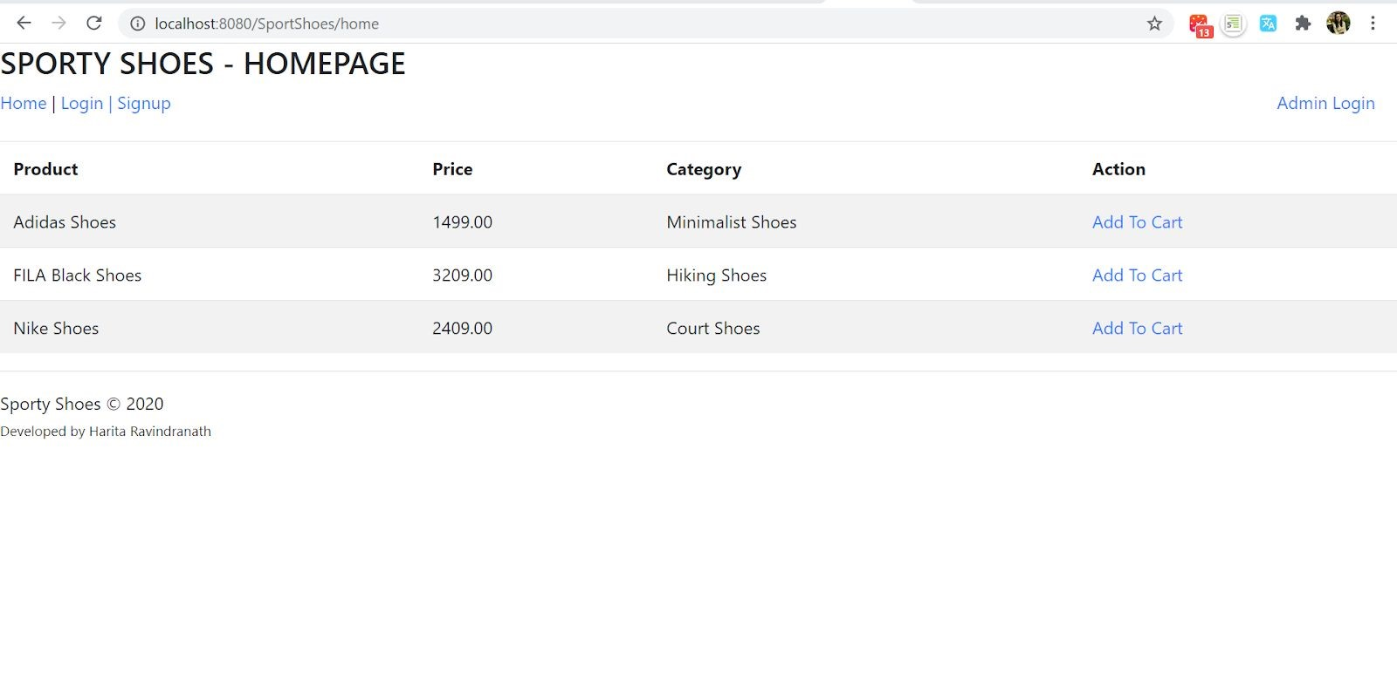

**2.**

**User tries to ADD TO CART without Logging in**

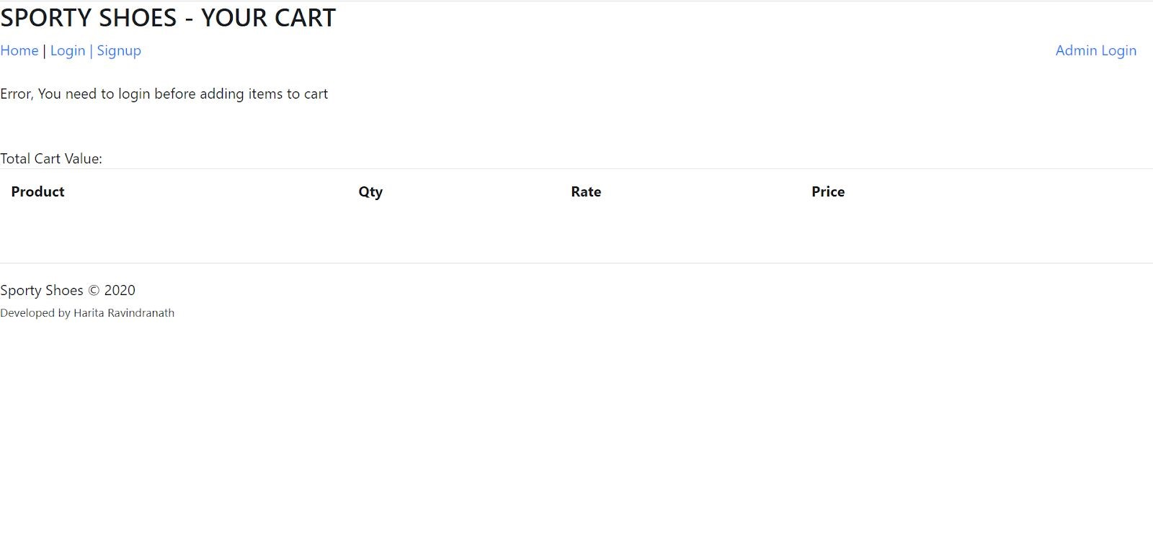

## 3. Login Page

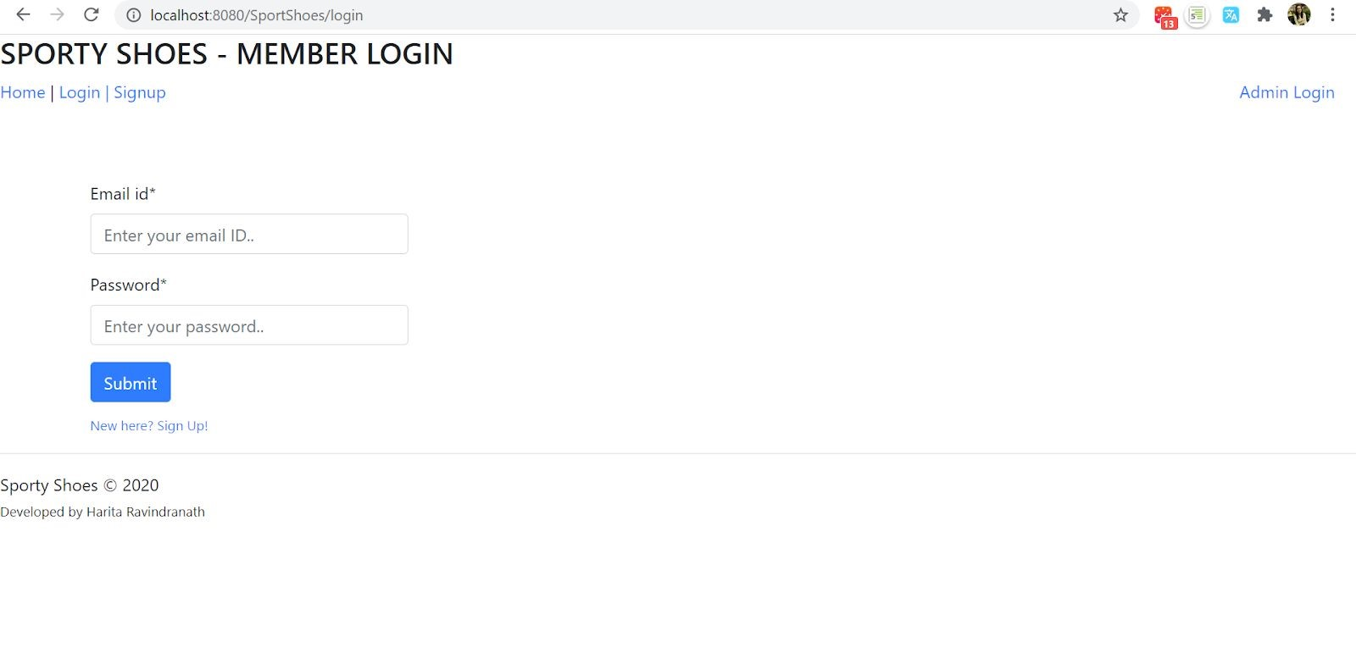

### 3.1 Login - Invalid Credentials

When the user enters invalid credentials, the input fields are reset & an error message is displayed

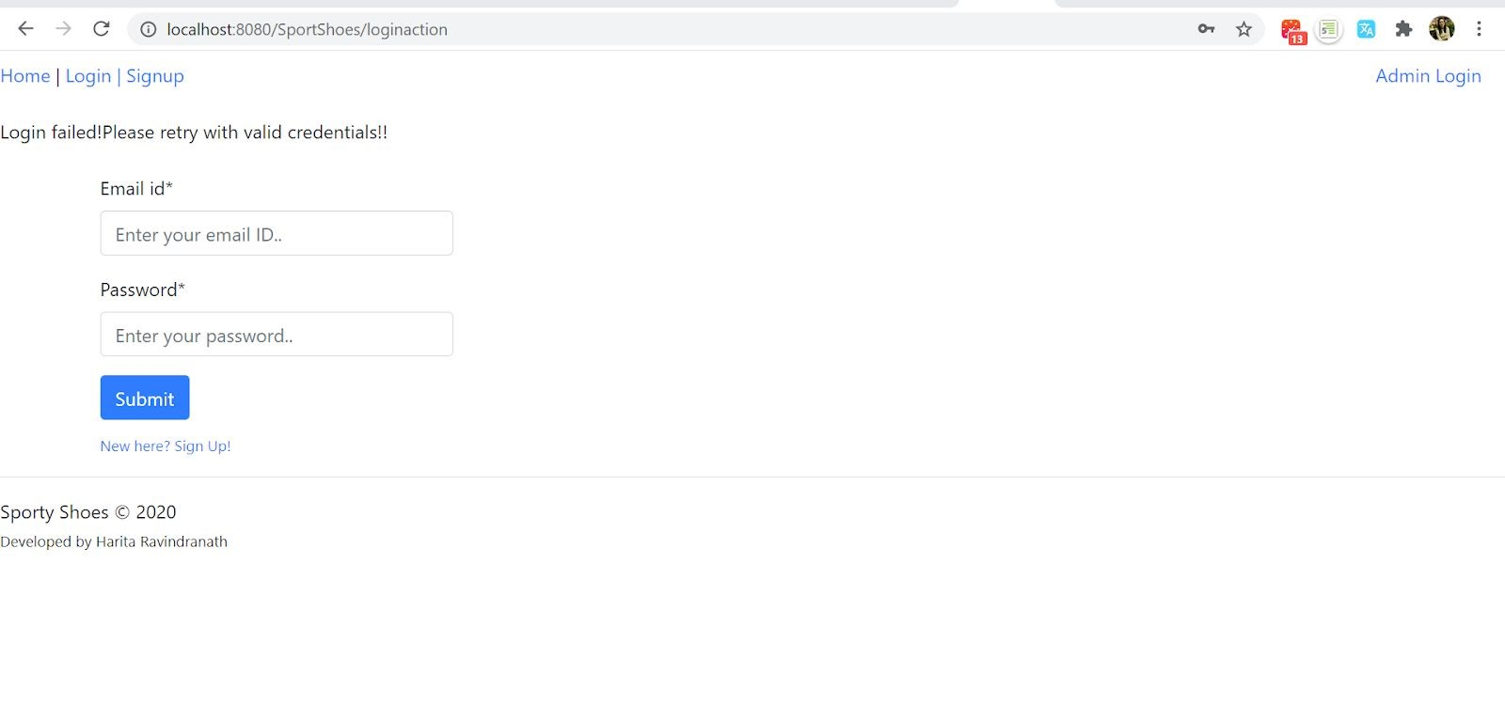

## 4. Sign Up Page

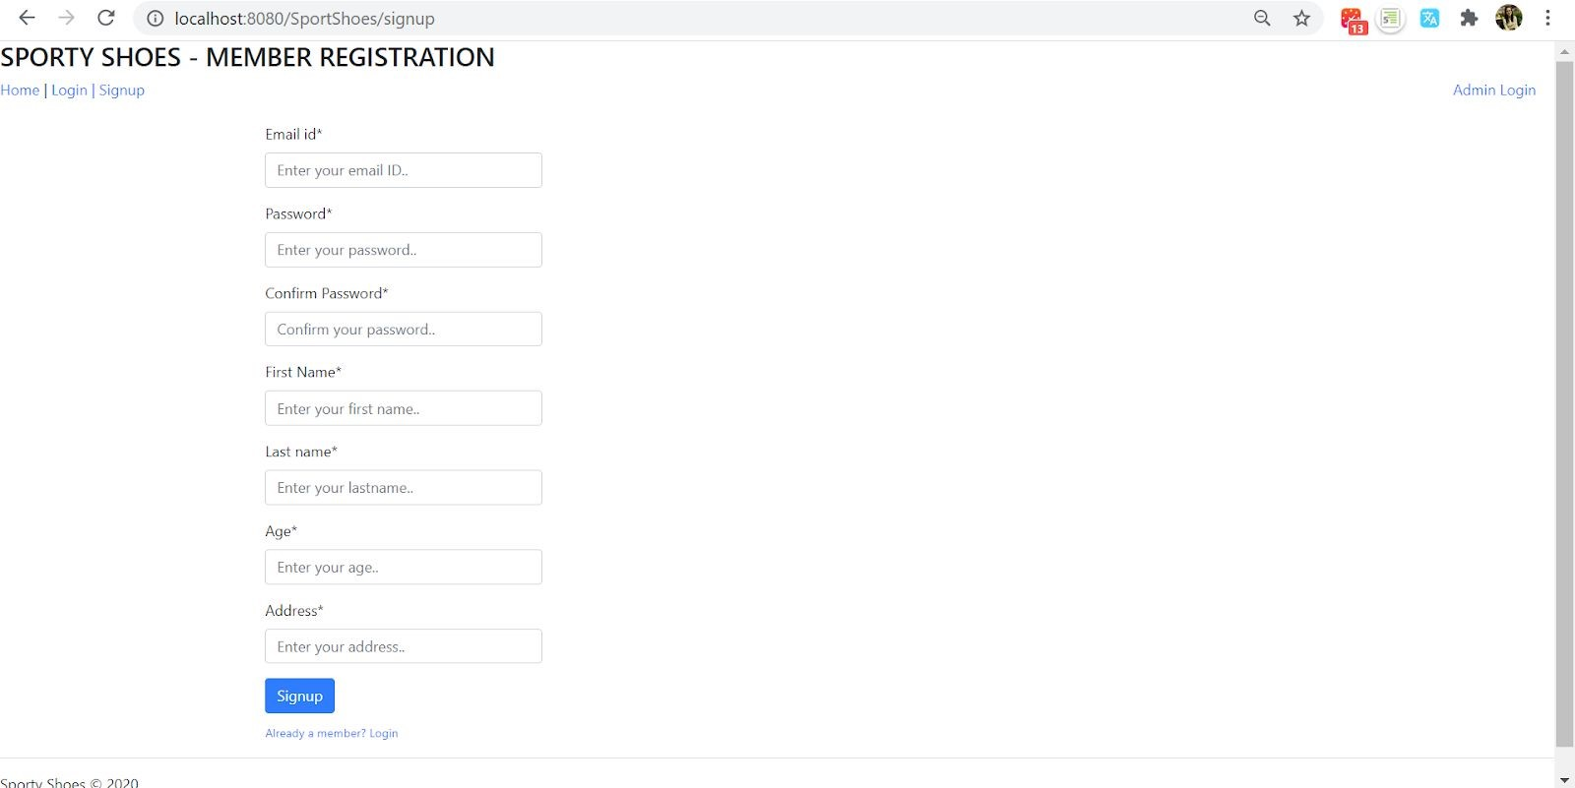

**4.1**

**Sign Up - Success**

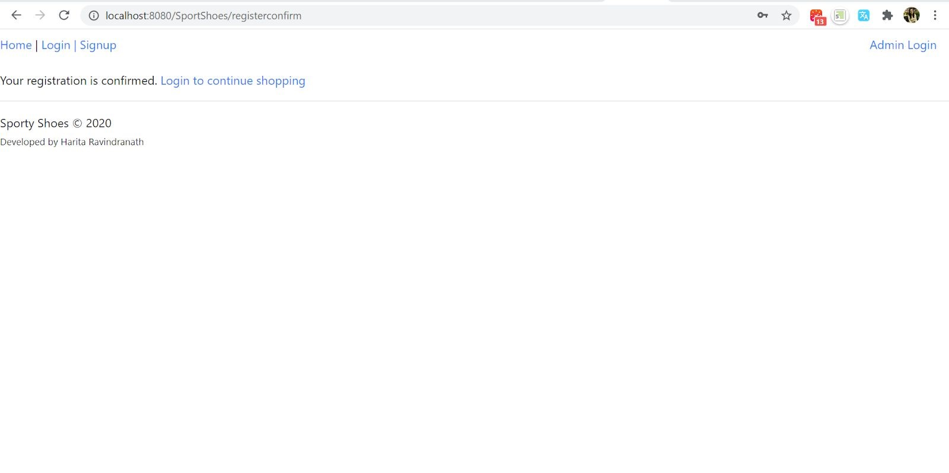

## 5. User Dashboard

Page presented to the user after logging in.

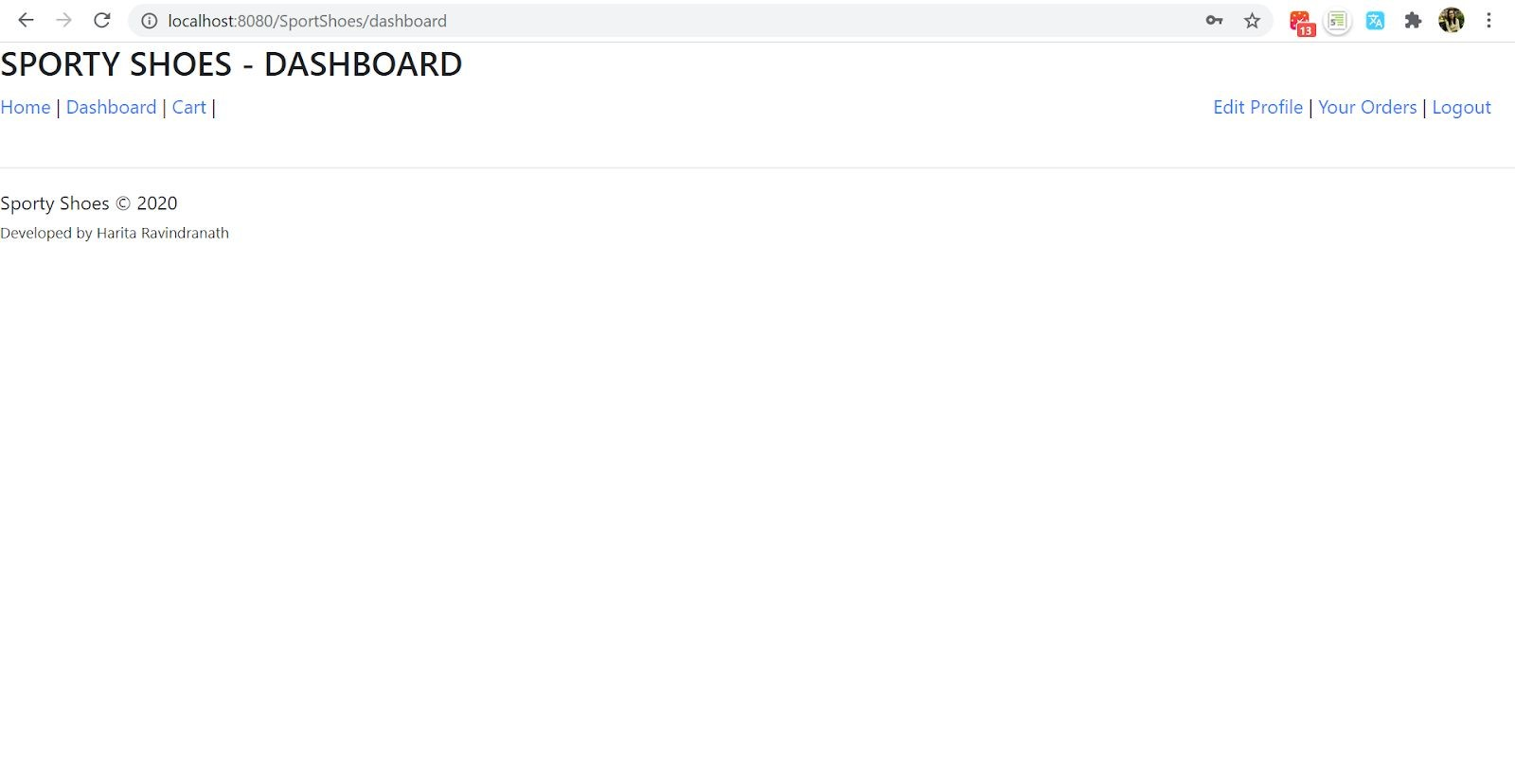

**6.**

**User Home page**

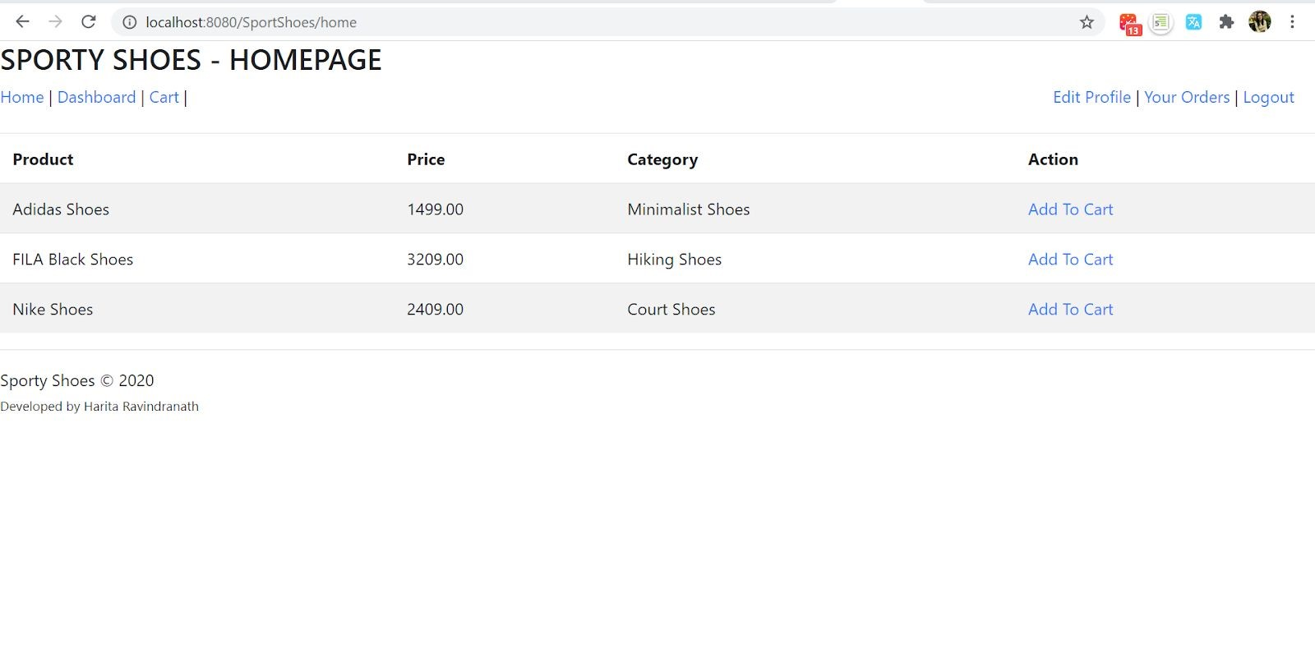

**7.**

**User CART - After adding product**

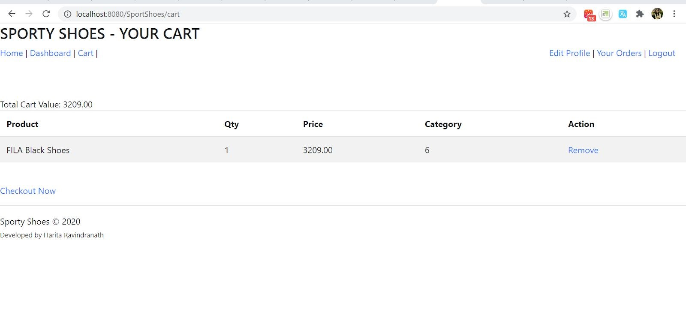

**8.**

**Checkout Page**

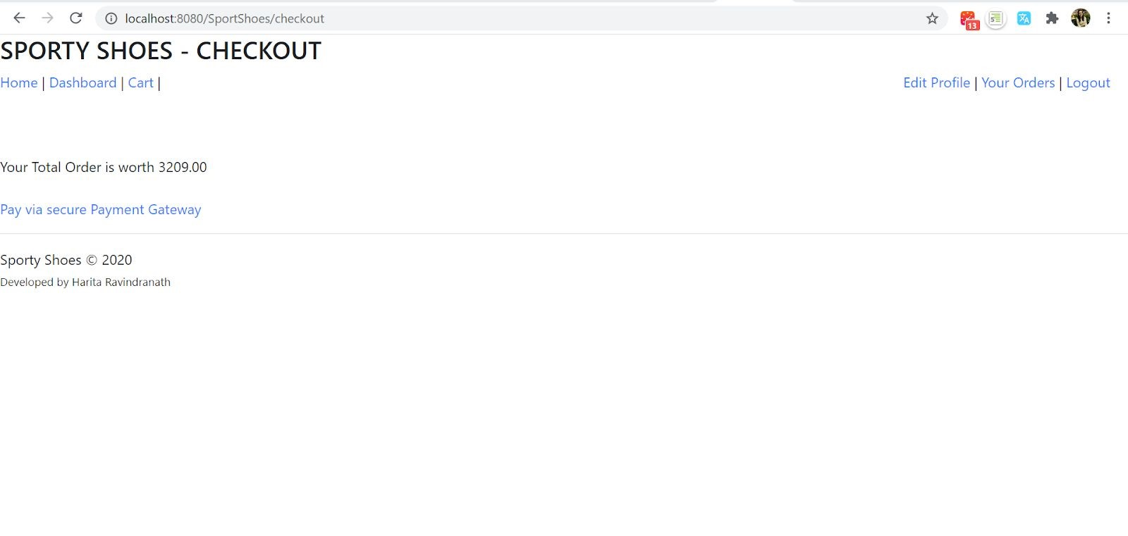

**9.**

**Payment Gateway**

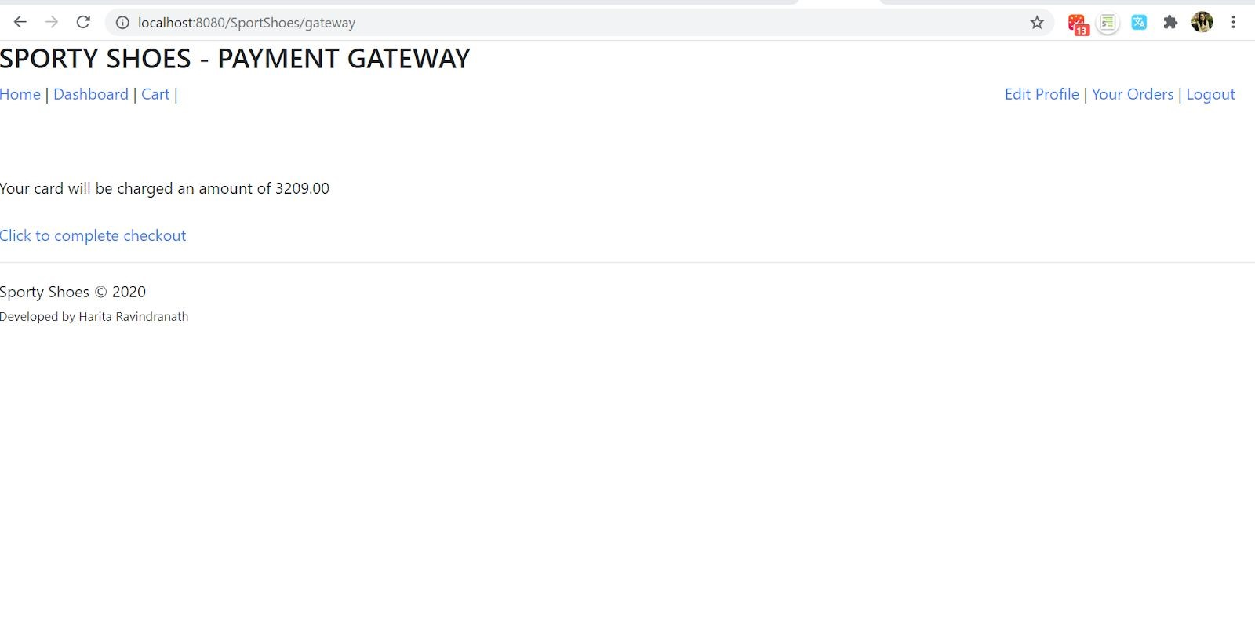

**10.**

**Payment Success**

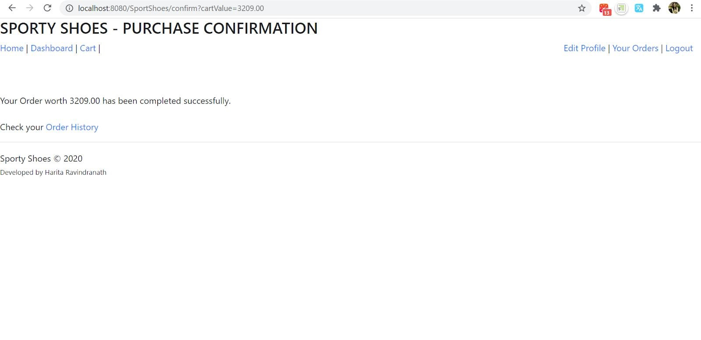

### 11. View Order History

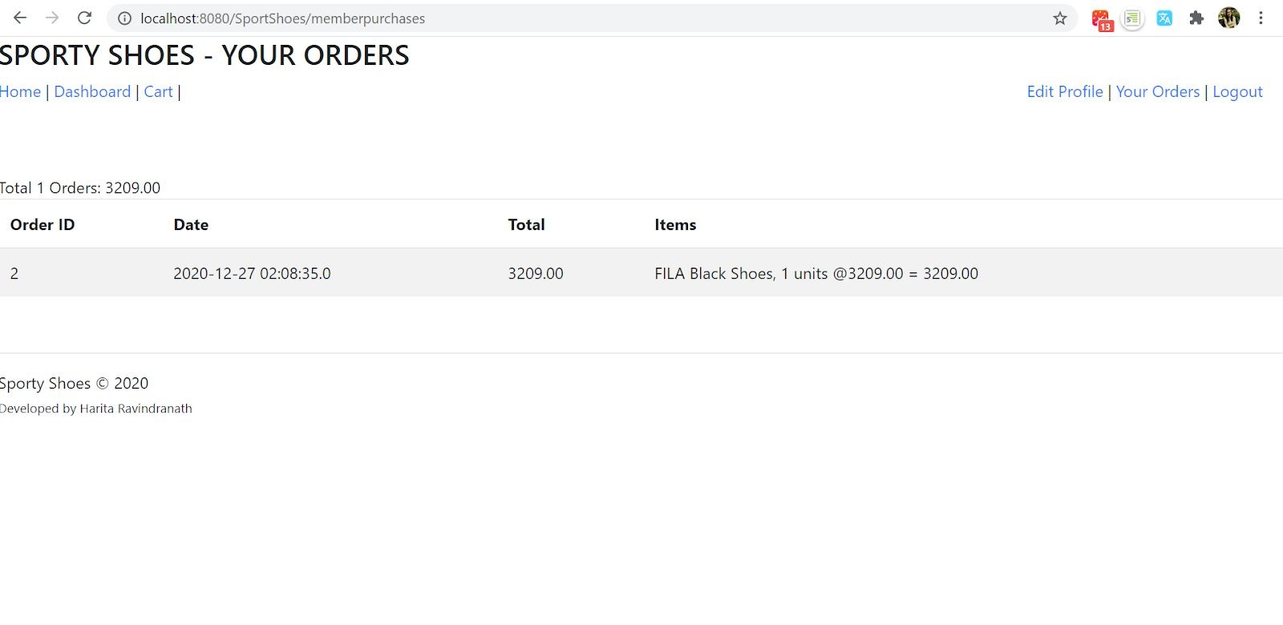

**12.**

**Edit Profile**

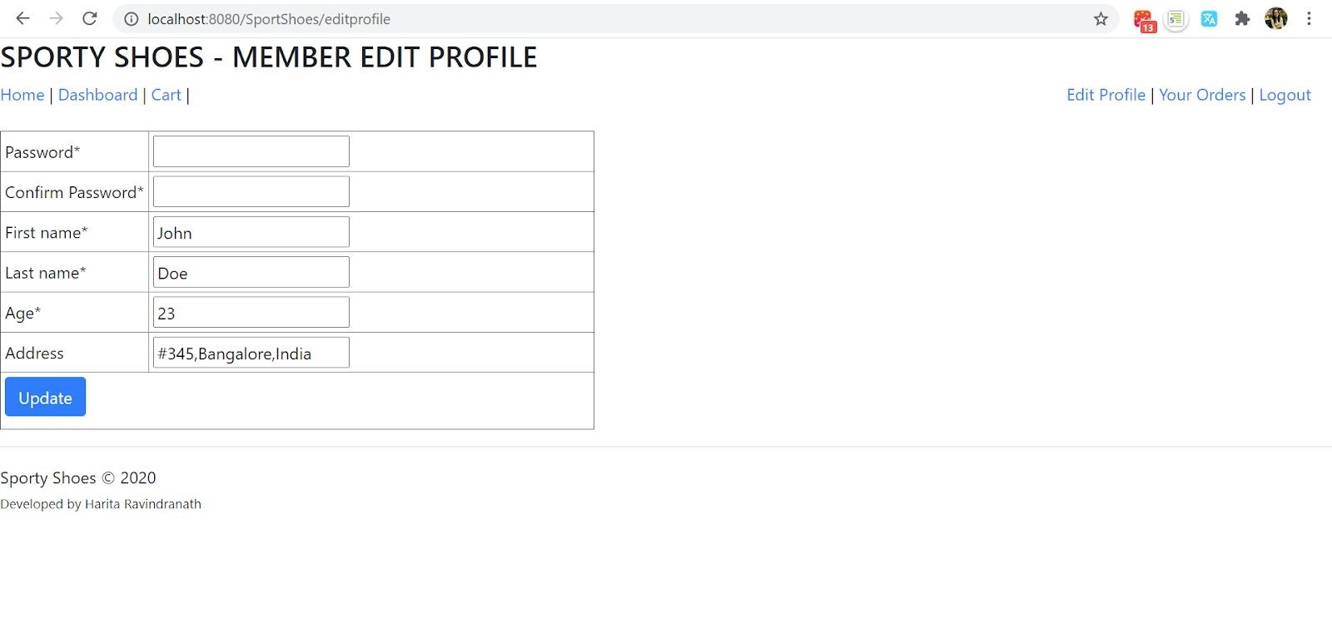

## 13.User Logout - navigated to Home Page

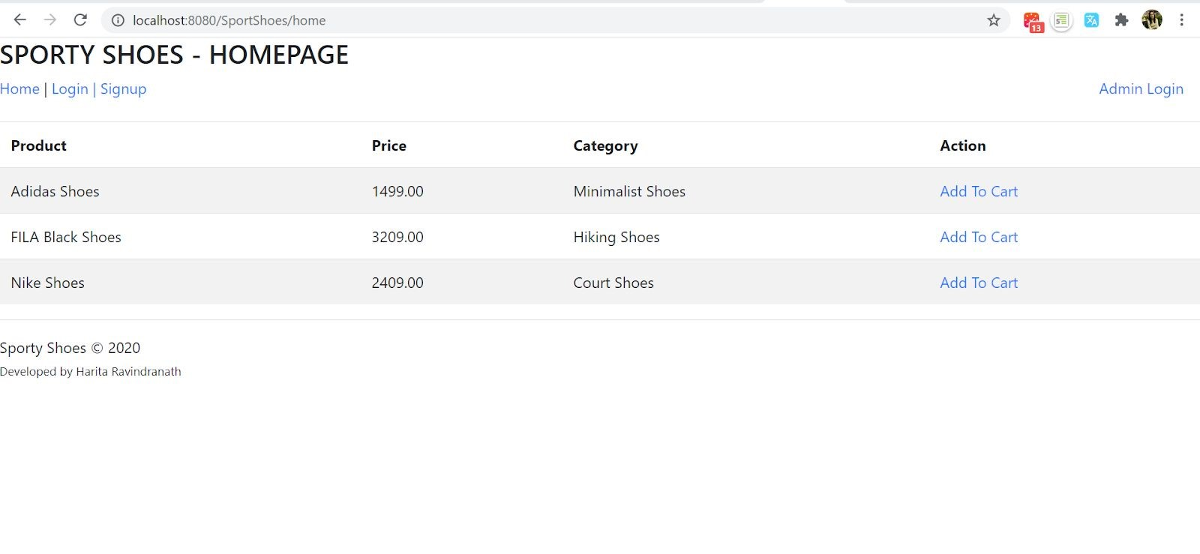

# ADMIN FRONT-END

**14**

**. Admin Login**

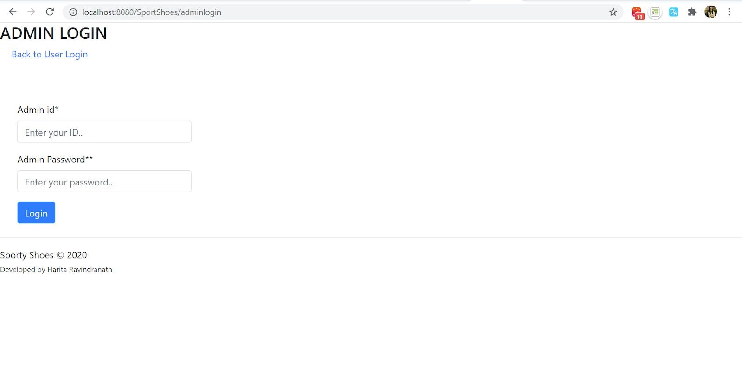

**14.1 Login - Invalid Credentials**

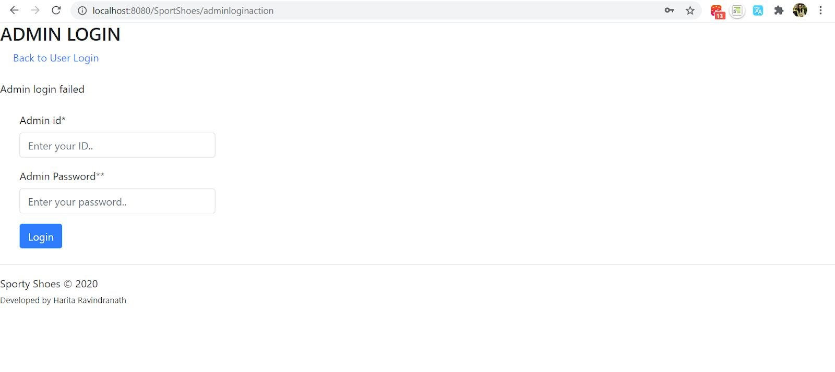

**15**

**. Admin - Dashboard**

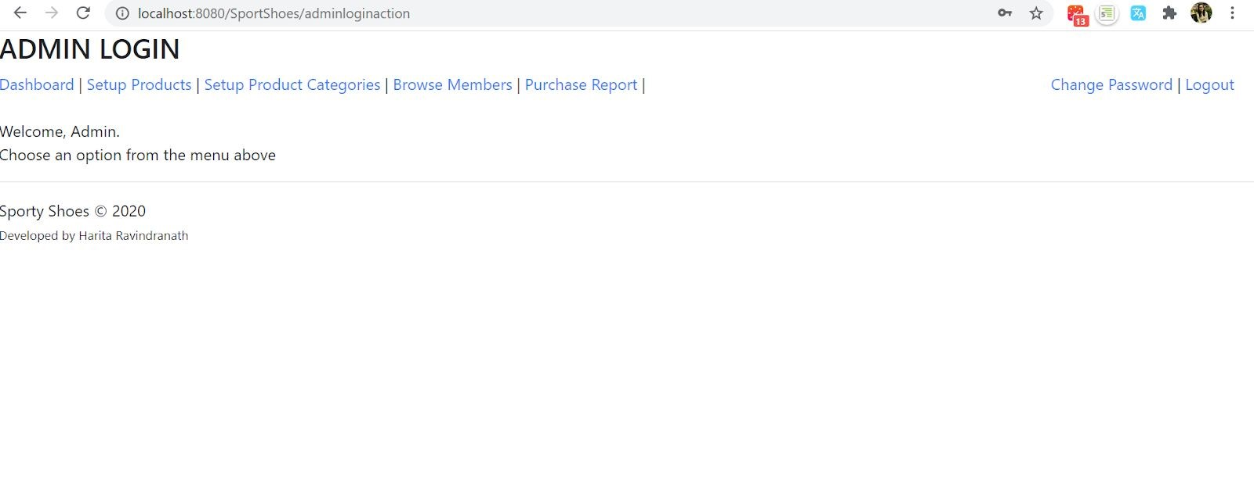

## 16. Add a Product

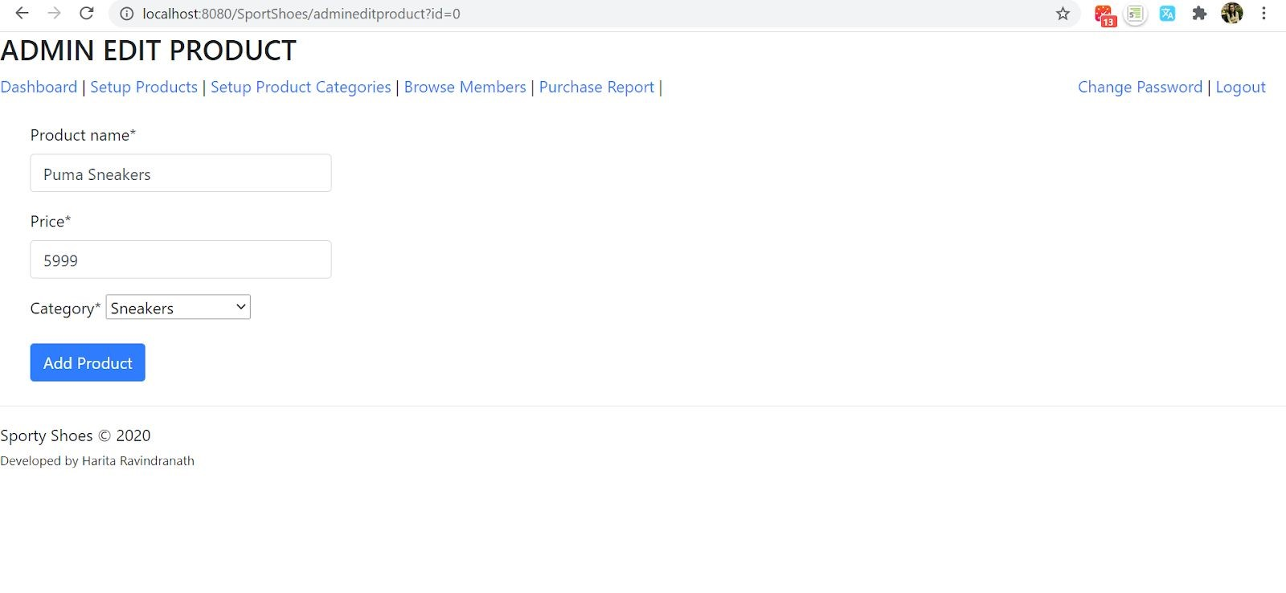

**17**

**. View Products**

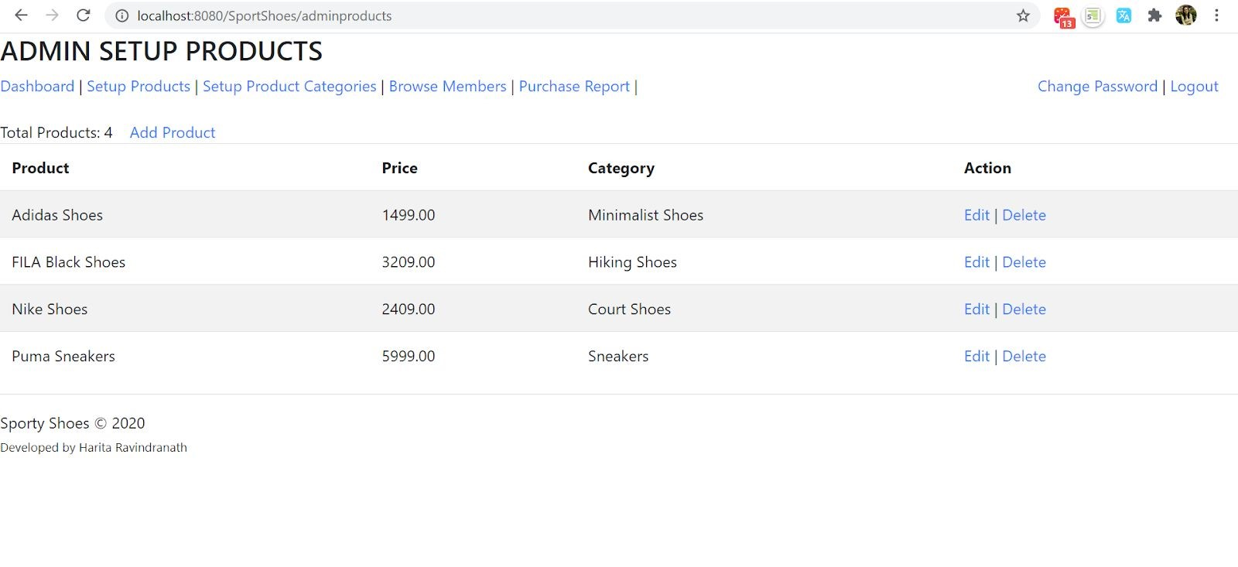

## 18. Edit a product

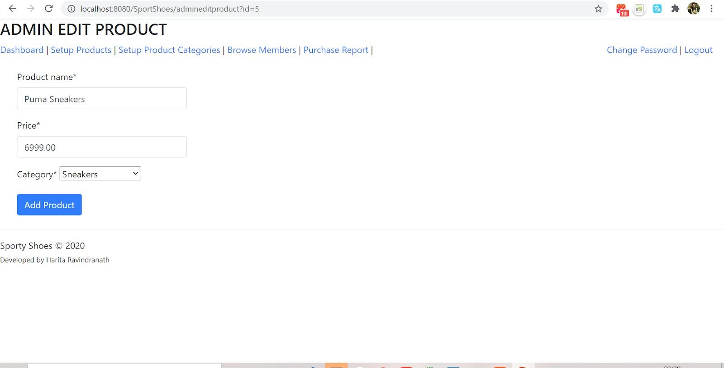

**18.1 View the edited Product**

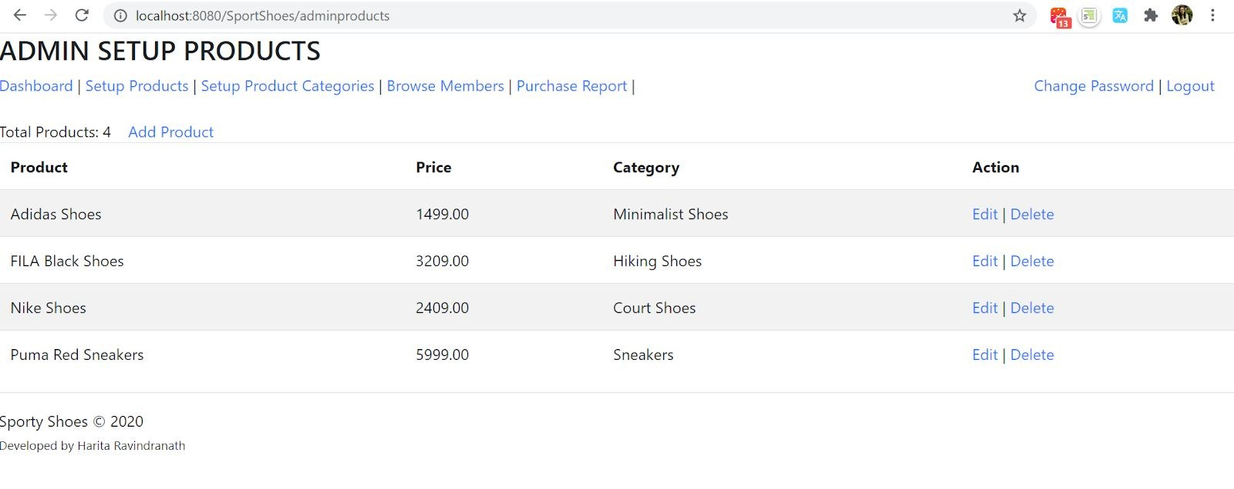

### 19. Add a Category

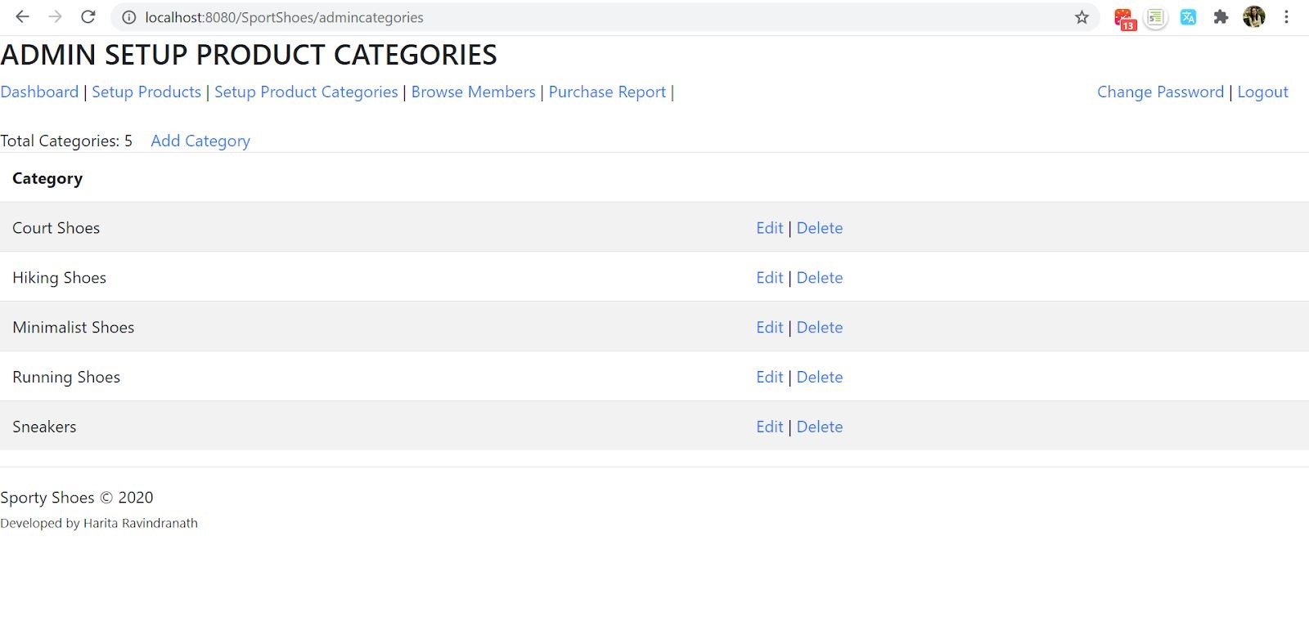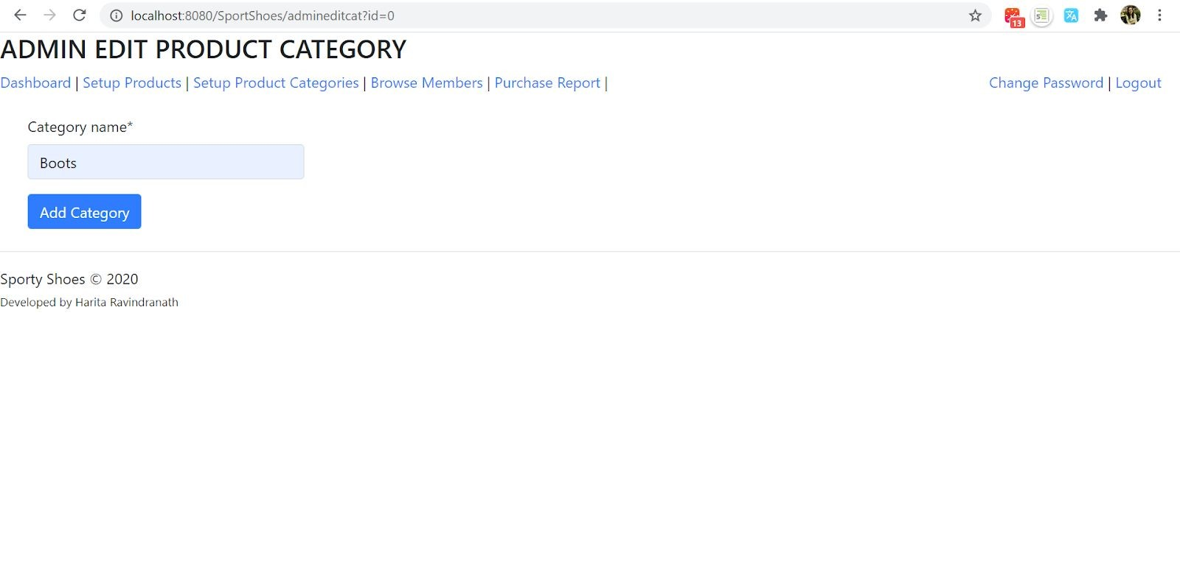

### 20. View Categories

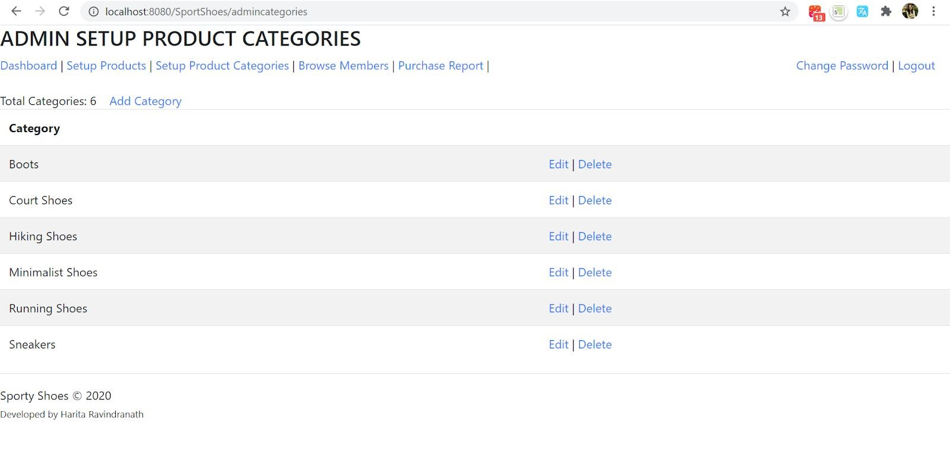

### 21. Browse User Details

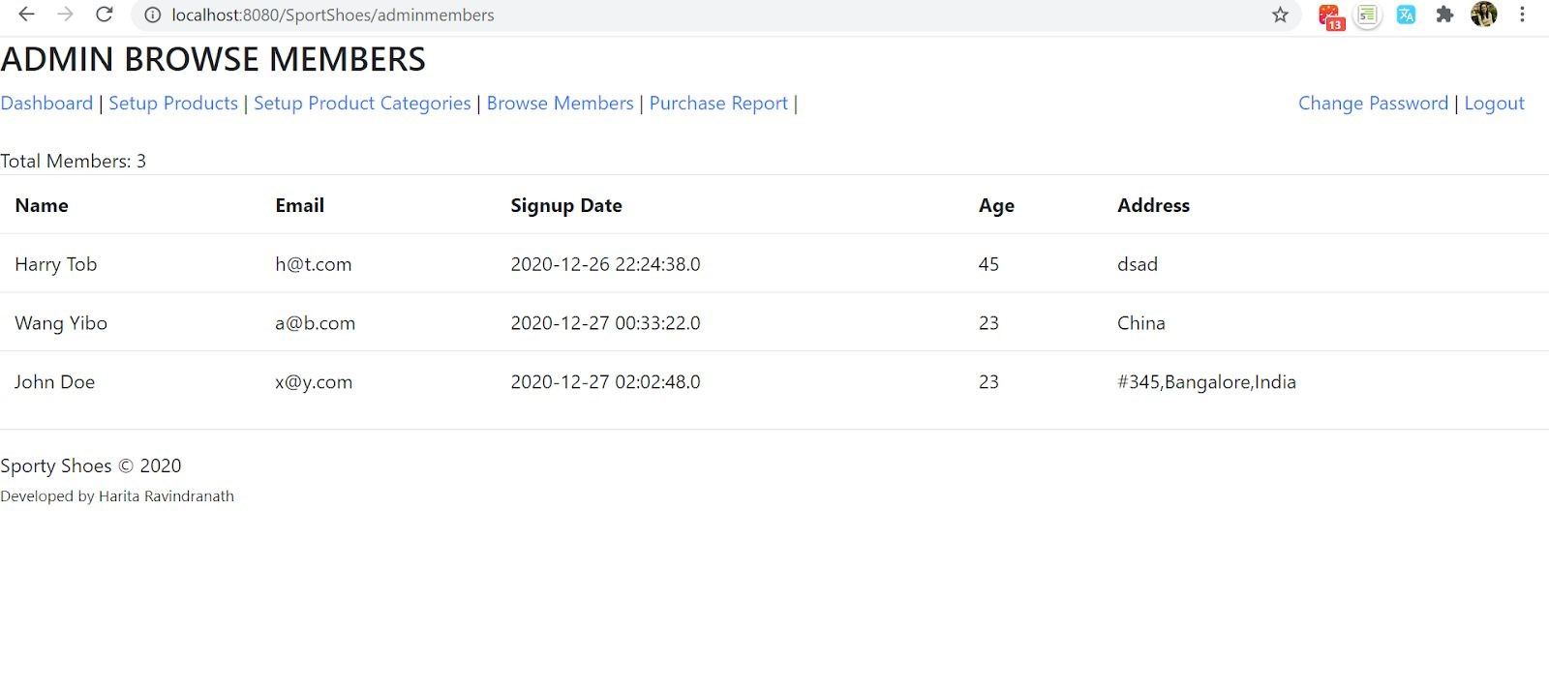

### 22. View Purchase Report

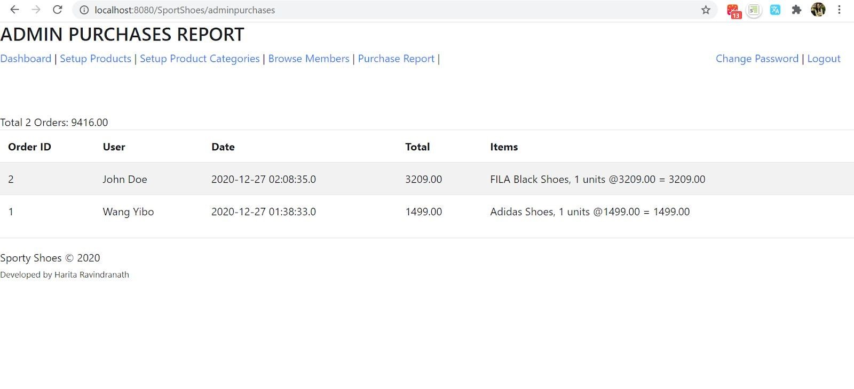

**23**

**. Change Password**

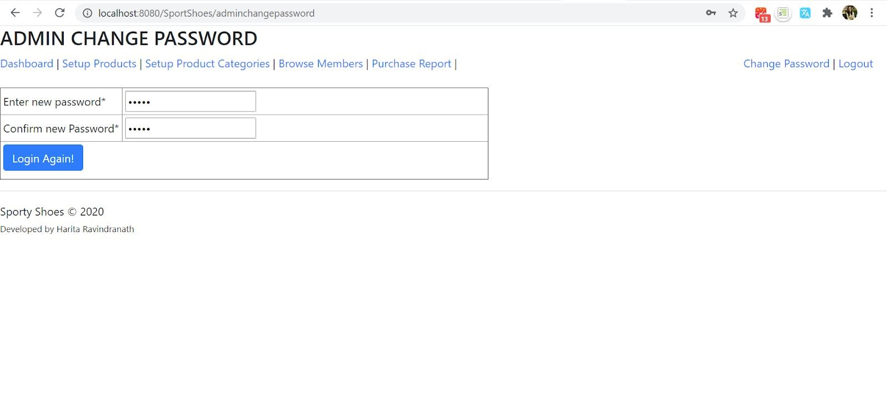

Navigates back to the Home page.

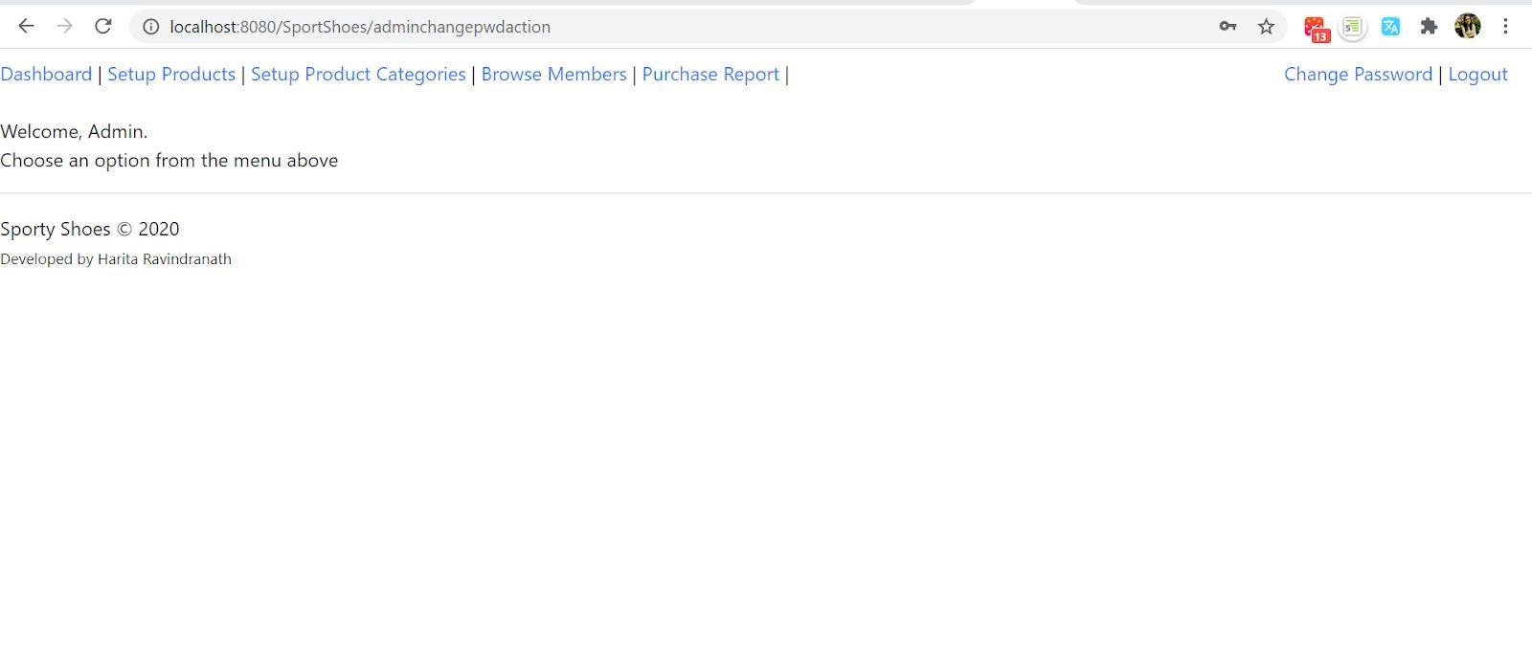

**24. Logout - Back to Admin Login Page**